Iris Screen Exporter
Will Hartsell
Saturday, May 7, 2022
Contents
Iris Screen Exporter 1
Overview 2
The iris.xml configuration file 2
The Iris-Server 3
Menu Bar 4
Viewport Tabs 4
Iris – Client 5
Viewport Windows 6
Known Issues 7
Change Log 7

Overview
Iris allows you to define “viewports” on your screen that will be captured and exported over the network via UDP to be displayed on another machine. All of the settings are stored in the iris.xml configuration file. Both the Iris server and Iris client can share the same configuration file. This makes it possible to install Iris on a shared drive and run the executable files on different computers.
Iris was inspired by Gremlin77’s Visual Basic based Screen Exporter. http://forums.eagle.ru/showpost.php?p=1696987&postcount=183

The iris.xml configuration file
Before starting Iris you need to create an “iris.xml” configuration file. An example is included in the install directory and in the appendix of this manual. All coordinates are in pixels with (0,0) being the top left corner of the display.
<ViewPorts> Defines a list of viewports.

<ViewPort> Defines an individual viewport.

<Host> Defines the hostname of the client that will be rendering the viewports. Localhost, Hostname, or IP are all valid.

<Port> Defines the port that the individual viewport will listen to. Make sure you pick an unused port and it is allowed through your firewall.

<ScreenCaptureX/Y> Define the (X,Y) coordinate of the top left corner of the viewport to be captured.

<SizeX/Y> Define the horizontal, vertical size of the viewport to be captured.

<ScreenPositionX/Y> Define the (X,Y) coordinate of the top left corner of the position of the viewport to be rendered on the client. This can be manually set in the configuration file or be saved at runtime by the
client. See the client section for details.

The Iris-Server
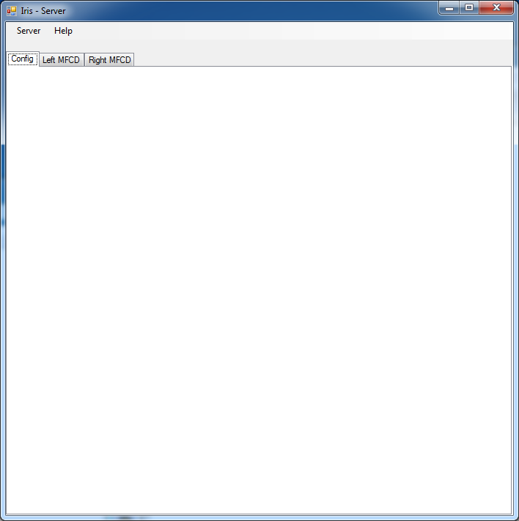
Iris-Server is the executable responsible for capturing and sending the viewports over the network. For every viewport defined in the “iris.xml” file it will capture that viewport and send it via UDP to the corresponding host/port defined. Since host/port is defined for each viewport it is possible for a single server to send viewports to many clients running on multiple machines. The viewports are sent at a rate of 10 per second. Depending on the size of your viewports this can result in allot of data being sent out on your network. For best results do now use a wireless network. If you are worried about congesting your network it is possible to use a dedicated network for just Iris traffic or even a crossover cable.

The Iris-Server Window contains a Menu Bar, Configuration Tab, and a Tab named for each viewport defined in iris.xml

Menu Bar
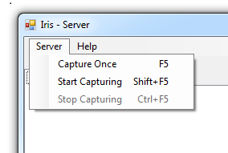
The Menu Bar contains options for starting and stopping the viewport capturing process. Each option also lists an associated hot key.

Capture Once - Performs a single capture into each viewport.
Start Capturing – Starts the capturing process
Stop Capturing – Stops the capturing process

Viewport Tabs
For every defined viewport in iris.xml a tab is created that displays what is being captured in the current viewport. When you turn on capture this display will be updated a capture takes place. This allows you to verify the server is “seeing” what you want it to see in each viewport.
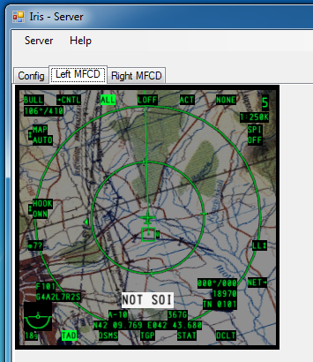
In the example to the left you can see that the viewport named “Left MFCD” is displayed. It is currently showing the TAD view in the A-10’s left MFCD.

Iris – Client

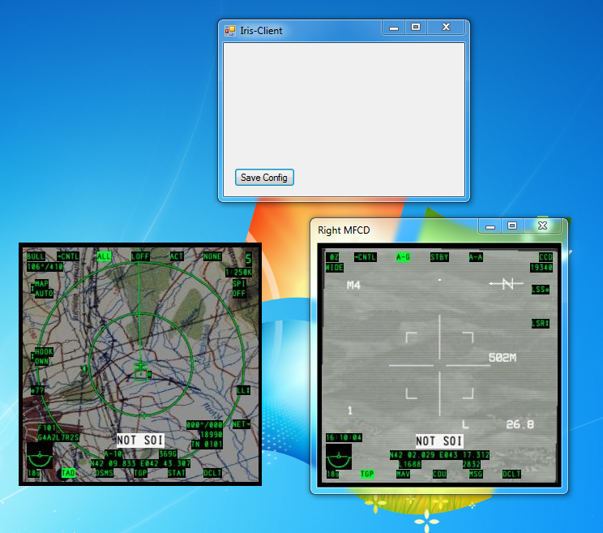
The Iris-Client is run on the machine you want to send the viewports to. It receives the viewports sent by the Iris-Server via UDP. If you are running a firewall ensure that it is configured to allow the ports you defined in you iris.xml file. The Iris-Client has two main components. The main window and a viewport window for each viewport defined.
The Main Iris-Client window has only one button. It allows you to save the viewport’s window locations to iris.xml so you don’t have to position them each time you start up the client.

Viewport Windows

Each defined viewport will have its own window. The window has two modes. With borders and without borders. When borders are on the window can be dragged just like any other window. This allows for coarse window positioning. When borders are off the window cannot be dragged to be moved. In the example above the window on the left has no borders, while the window on the right does.

Viewport Context Menu
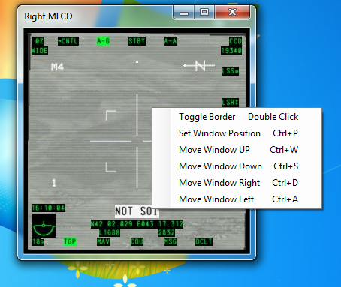
Each viewport window has a context menu that is accessed by right clicking on the window. The menu lists all actions you can take on the window and their associated hot keys.
Toggle Border – toggles between showing and hiding the border of the window.
Set Window Position - This sets the current windows position in the running configuration. This does NOT save the position to iris.xml. That is performed by the “Save Config” button on the main window.
The last four window actions allow you to fine tune the window position. This works regardless of if the border is on or off. Each click moves the window 1 pixel in the selected direction. A More efficient way to position the window is to use the traditional WASD keys while holding either Control key.

Known Issues
The issues for Iris Screen Exporters can be viewed at https://github.com/HeliosVirtualCockpit/Iris-Screen-Exporter/issues?q=is%3Aissue
- Flickering on client displays can happen due to Screen Capture failing intermittently because Vsync is not enabled on the Server side machine. https://github.com/HeliosVirtualCockpit/Iris-Screen-Exporter/issues/1

Change Log

1.0.2022.0507
- Moved into HeliosVirtualCockpit parent directory
- Added forms icons
- Installation back to all users
- Forms Title text for Server and Client changed to Iris Screen Exporter –
- Updated PDF instructions with known issues section

1.0.2020.0531
- Changed build to Any CPU to allow to be installed on 32 bit systems which might be running clients for a single screen. This means that on 64 bit systems, it could be installed in Program Files(x86) now.
- Moved the installation out of the "IRIS" sub directory
- Improved and corrected the error messages for network errors and "Message Too Large" in particular.
- Installation default is now just for the current user rather than all users.

1.0.2019.0316
- Background capability added so that a single color window will be opened if the name of the viewport is “Background” (case sensitive).
- Command line argument can be used to specify the configuration xml file (default remains iris.xml)
- Several bug fixes.

The name of the xml configuration file can be specified as a command line option when starting the server and client
If the Viewport name is “Background” this is auctioned only by the client and creates a window which is a single color and then sends it to the back of the viewport stack to act as a background. This can be useful to block out the desktop.

